# Assignment-4

PythonProgramming

|  |  |
| --- | --- |
| AssignmentDate | 02 November2022 |
| StudentName | Sridhar. N |
| StudentRollNumber | 732919ECR137 |
| MaximumMarks | 2 Marks |

# Question-1:

Writecode andconnectionsinwokwiforultrasonicsensor.

Whenever distance is less than 100 cms send "alert" to ibm cloud and display in device recentevents.

Uploaddocumentwithwokwishare link andimagesofibm cloud.

# Solution:

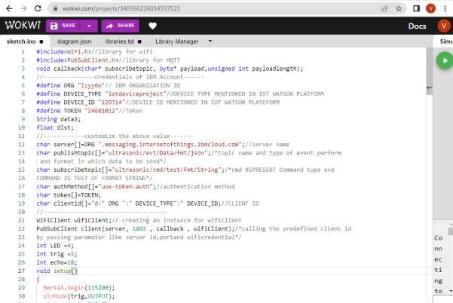

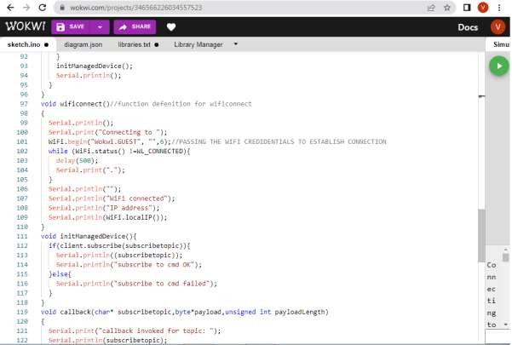

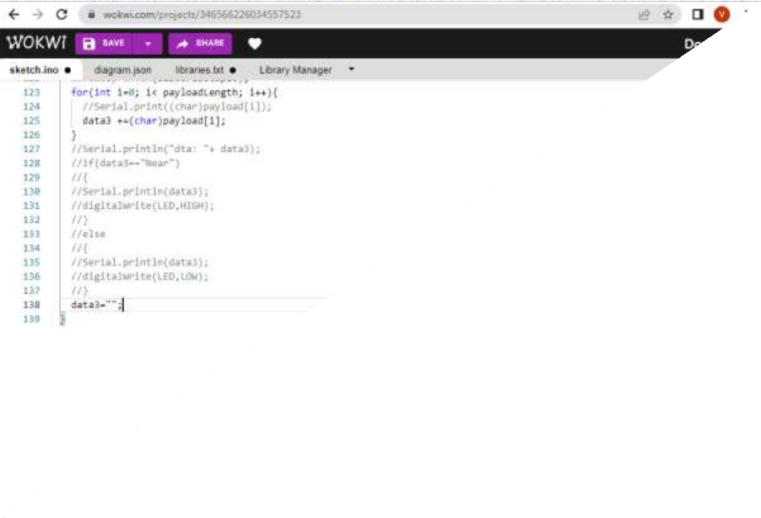

OUTPUT:

DATAISSENTTOIBMCLOUDWHENNO OBJECTISDETECTED

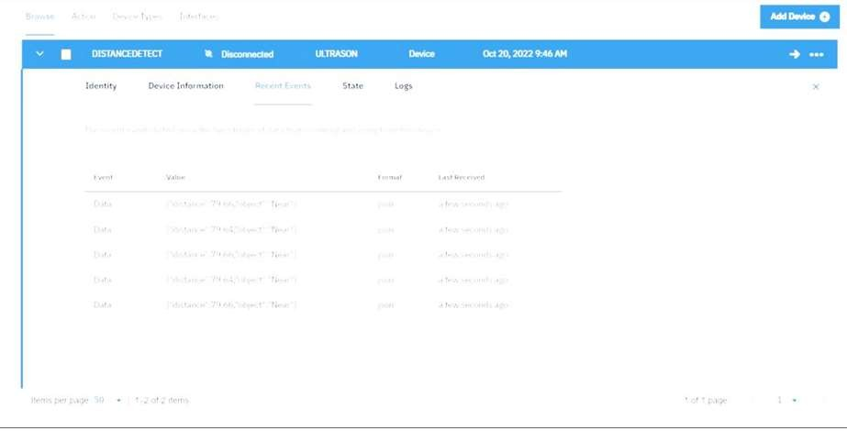

Whennoobject isdetected



Whenobjectis detected inultrasonic detector

